|  |
| --- |
| Kenny & patic |
| Final |
| Documentation of surveys 2014  C:\Users\Kenny\AppData\Local\Microsoft\Windows\INetCache\Content.Word\logo.png |
| Version #  All work Copyright © 2012 by Kenny & Patrick. design.  All rights reserved. |
| **Kenny & Patrick** |
|  |

|  |
| --- |
| April 16 2014 |

**Table of Contents**

|  |  |
| --- | --- |
| **Name** | **Page Number** |
| **Version History** | 3 |
| **Brief description** | 4 |
| **Nav bar** | 4 |
| 1. **Color** | 4 |
| 1. **Interface Sketch** | 5 |
| 1. **Topography section** | 6 |

**Version History**

[This is where you keep track of the detailed changes made to your document throughout the course of development.]

https://github.com/Thaviel/FinalPressSurvey/commits/master

1. **Brief Description**

This is a website of 3 parts

* 1. Part a is the initial page where you can see a slider and an introduction.
  2. Then there is a section of content in html and plugins.
  3. And finally a copyright footer.

1. **Nav bar**
   1. 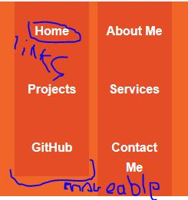
2. **Color**

|  |  |  |  |  |
| --- | --- | --- | --- | --- |
| f16529 | #e44d26 | #ccc | #222 | #b3d4fc |
| ██████████ | ██████████ | ██████████ | ██████████ | ██████████ |

1. **Interface Sketch**

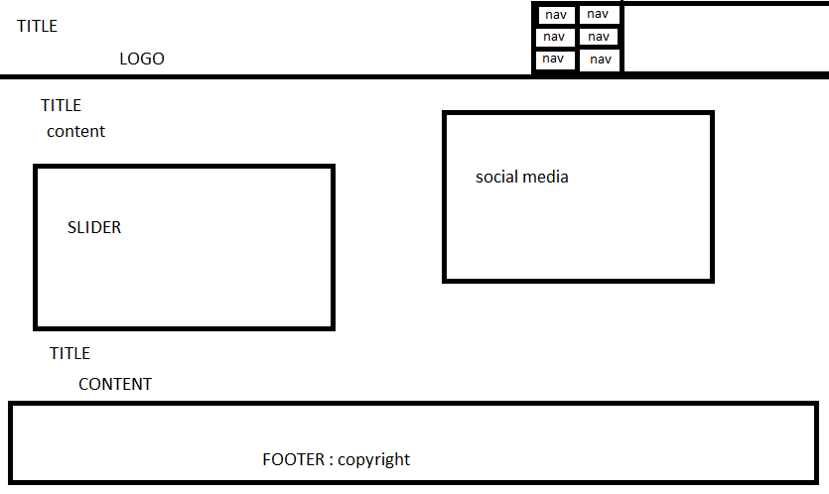

**V: Typography section:**

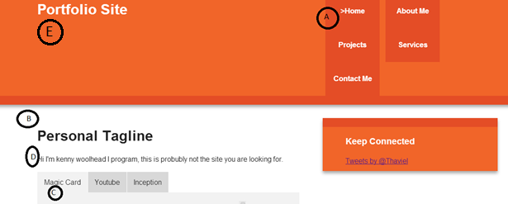

**16**

**26**

|  |  |  |
| --- | --- | --- |
| **SECTION** | **FONT SIZE** | **COLOR** |
| **A** | 1em Helvetica, Helvetica Neue, Arial; bold | **white** |
| **B** | 2em | **black** |
| **C** | 1em | **black** |
| **D** | 1em | **black** |
| **E** | 2em bold | **white** |